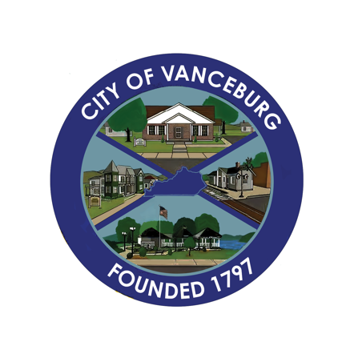
PRESS RELEASE
CITY OF VANCEBURG
189 Second Street, Vanceburg, KY 41179 | 606-796-3044
Email: Marketing@cityofvanceburg.com

August 10, 2023
Re: Party in the Park
From: Brenda S. Bear, City of Vanceburg

The City of Vanceburg held a “Party in the Park” on Saturday, August 5th in downtown Vanceburg. The Cruise-In included 102 vintage vehicles lining Main Street, Front Street and in the Vanceburg Christian Church Parking lot. Gayle McCord with Let’s Cruise Entertainment hosted the event and participated in giving away $1,000.00 in cash prizes, plus numerous other door prizes. Cars were from Kentucky, Ohio, West Virginia and as far away as Indiana. Thank you, Globe Family Funeral Homes for sponsoring the Cruise-In.

Nichole Cantu was responsible for the first annual Dog Show held in the Veteran’s Park.
Nichole registered 17 dogs and raised $345.00 for the Lewis County Animal Shelter. Several awards were given out such as Fabulous Fella, Prettiest Pup, Wiggliest Tail, and Overall Best in Show. Two dogs were adopted from the animal shelter during the show, which added to the success of the City’s first dog show! Thank you Bubbles and Board for being a sponsor.

The Power Wheel Race was held in the Merchant’s Lot with Ben and Leslie Collier organizing the event. We had two entries who won the show. Both power wheels were decorated red, white, and blue and both were declared winners of the race.

The theme of the night was the 50’s, 60’s era. Local band, Bustin’ Loose played live music from 7pm to 10pm. The event also included food trucks and a contest for best 50’s, 60’s attire. Thank you to our sponsors, Sunoco, McDonald’s, Chigger’s Dairy Bar, Back Alley Spirits, John Clark Oil and Vanceburg Food Mart.
Please mark your calendars for Saturday, September 2nd for Saturday in the Park. Follow the City of Vanceburg’s Facebook page to stay up-to-date with our upcoming events, photos and more.

