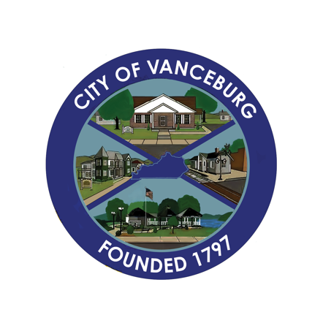
PRESS RELEASE
CITY OF VANCEBURG
189 Second Street, Vanceburg, KY 41179 | 606-796-3044
Email: Marketing@cityofvanceburg.com

September 15, 2023
Re: Scott Park Playground Equipment
From: Brenda S. Bear, City of Vanceburg

The City of Vanceburg has received a $5,734.00 donation from Lewis County Farm Bureau. The money was used to purchase three pieces of playground equipment for Scott Park.

Scott Park is located on Front Street and is primarily used by the residents who live in downtown Vanceburg. Mayor Blankenship wanted to focus on serving more families with handicap and sensory needs. A lot of research was completed to ensure the new equipment would be handicap accessible and safe and supportive. The new pieces are the Cozy Cocoon, the Spin Cup, and the Swing.

Mayor Dane Blankenship and the City of Vanceburg would like to say thank you to Lewis County Farm Bureau for their assistance in updating Scott Park and creating a safer environment for our children.

